**3rd EYE FOR THE BLIND**

**A PROJECT REPORT**

***Submitted by***

**RIYAZ AHAMED A 411516106054**

**SANTHOSH M 411516106056**

**VAIRAMUTHU K 411516106063**

**VIGNESH N 411516106064**

***in partial fulfillment for the award of the degree***

***of***

**BACHELOR OF ENGINEERING**

**IN**

**ELECTRONICS AND COMMUNICATION ENGINEERING**

 

**PERI INSTITUTE OF TECHNOLOGY, CHENNAI**

**ANNA UNIVERSITY : CHENNAI 600 025**

**APRIL 2020**

**ANNA UNIVERSITY : CHENNAI 600 025**

**BONAFIDE CERTIFICATE**

Certified that this project report **“ 3rd EYE FOR THE BLIND ”** is the bonafide work of **“RIYAZ AHAMED (411516106054), SANTHOSH (411516106056) , VAIRAMUTHU (411516106063), VIGNESH (411516106064) ”** who carried out the project work under my supervision.

**SIGNATURE SIGNATURE**

Mrs. Abisha J. Benelyn , M.E. Mrs. Abisha J. Benelyn, M.E.

**HEAD OF THE DEPARTMENT SUPERVISOR**

ASSISTANT PROFESSOR, ASSISTANT PROFESSOR,

Department of Electronics and Department of Electronics and

Communication Engineering, Communication Engineering,

PERI Institute of Technology, PERI Institute of Technology,

Mannivakkam, Mannivakkam,

Chennai-600048. Chennai-600048.

Submitted for the university examination held on ………………….

**INTERNAL EXAMINER EXTERNAL EXAMINER**

**TABLE OF CONTENTS**

**CHAPTER NO. TITLE PAGENO.**

**ABSTRACT**

**LIST OF TABLE xvi**

**LIST OF FIGURES xviii**

**LIST OF SYMBOLS xxvii**

**1 INTRODUCTION**

1.1 GENERAL

1.2 OBJECTIVE OF THE PROJECT

1.3 AIM OF THE PROJECT

**2 LITERATURE REVIEW AND**

**DISCUSSION**

2.1 INTRODUCTION

2.2 LITERATURE REVIEW

**3 EXISTING SYSTEM**

3.1 INTRODUCTION

3.2 WORKING OPERATIONS

3.3 SYSTEM ARCHITECTURE

3.4 CONCLUSION

**4 PROPOSED SYSTEM**

4.1 INTRODUCTION

4.2 BASIC SYSTEM ARCHITECTURE

**5 CONTROLLER BLOCK**

5.1 ARDUINO UNO

5.2 SENSORS

5.2.1 ULTRASONIC SENSOR

5.2.2 PIR SENSOR

**6 REQUIREMENTS**

6.1 HARDWARE REQUIREMENTS

6.1.1 ARDUINO BOARD

6.1.1.1 ARDUINO UNO

6.1.1.2 ARDUINO NANO

6.1.2 ULTRASONIC SENSORS

6.1.3 PIR SENSOR

6.1.4 GPS

6.1.5 GSM

6.1.6 BUZZER

6.1.7 VIBRATION MOTOR

6.1.8 LEDs

6.1.9 SWITCHES

6.2 SOFTWARE REQUIREMENTS

6.2.1 ARDUINO SOFTWARE

6.2.2 ARDUINO FEATURES

**LIST OF TABLES**

**TABLE NO INDEX**

5.1 ELECTRIC PARAMETER OF

ULTRASONIC SENSOR

5.2 DIFFERENCE BETWEEN ULTRASONIC

AND IR SENSOR

5.3 ELECTRIC PARAMETER OF PIR SENSOR

6.1 PIN CONFIGURATION OF 3 PIN SWITCH

**LIST OF FIGURES**

**FIGURE NO INDEX**

3.1 EXISTING SYSTEM MODEL

3.2 CIRCUIT DIAGRAM OF THE DEVICE

3.3 DETAILED CIRCUIT DIAGRAM

3.4 ANGLE OF FIELD

4.1 BLOCK DIAGRAM OF MAIN CONTROL BLOCKS

4.2 WORKING MODEL OF BLOCK DIAGRAM

4.3 BLOCK DIAGRAM OF RIGHT AND LEFT SIDE

BLOCKS

4.4 BASIC SYSTEM ARCHITECTURE

5.1 ARDUINO UNO

5.2 ULTRASONIC SENSORS

5.3 ULTRASONIC SENSOR DETECTION

5.4 TIMING DIAGRAM OF ULTRASONIC

SENSOR

5.5 PIR SENSOR

5.6 PIR SENSOR CONNECTION DIADRAM

5.7 SCHEMATIC DESIGN OF PIR SENSOR

5.8 WORKING OF PIR SENSOR

5.9 TIMING DIAGRAM OF PIR SENSOR

6.1 ARDUINO UNO

6.2 ARDUINO NANO

6.3 SCHEMATIC DESIGN OF ARDUINO NANO

6.4 ULTRASONIC SENSOR

6.5 PIR SENSOR

6.6 GPS

6.7 GSM

6.8 BUZZER

6.9 VIBRATION MOTOR

6.10 LEDS

6.11 WORKING OF LED

6.12 3 PIN SWITCH

6.13 SPDT SWITCH

6.14 4 PIN SWITCH

6.15 ARDUINO IDE

**ACKNOWLEDGEMENT**

First and foremost we place this project work on the feet of **GOD ALMIGHTY** who is the power of strength in each step of progress towards the successful completion of this project.

We are very much indebted to principal of our college, **Dr. R. PALSON KENNEDY, M.E., M.S., M.B.A., Ph.D.,** for his guidance and immense help in making this project a success.

We are highly indebted to **Mrs. ABISHA J. BENELYN, M.E., Assistant Professor ,Head of the Department, ECE** for her support and guidance.

We thank our project coordinator, **Mr. THIYAGARAJAN, M.E., Assistant Professor, ECE** for his support and guidance.

We would like to express our sense of profound gratitude and indebtedness to **Mrs. Abisha J. Benelyn, M.E., Assistant Professor, ECE** for her invaluable guidance, suggestion and timely supervision for successful completion of the project. We thank her for the great support with blessings.

We also extend our heartful thanks to all **staff member of ECE Department** who have rendered their valuable help in making this project successful.

We are very much indebted to our beloved parents and friends for their continuous support and encouragement throughout the project.

**ABSTRACT**

Third eye for people who are blind is an innovation which helps the blind people to navigate with speed and confidence by detecting the nearby obstacles using the help of ultrasonic waves and notify them with buzzer sound or vibration. They only need to wear this device as a band or cloth. According to WHO 39 million peoples are estimated blind worldwide. They are suffering a lot of hardship in their daily life. Now a days there are so many instruments and smart devices for visually impaired peoples for navigation but most of them have certain problems for carrying and the major drawbacks is those need a lot of training to use.Using the sensor,visually impaired candetect the objects around the mand can traveleasily.When the sensor detect sany object it will notify theuser by beep or vibration.Thus,this is an automated device.Thus this device will be of agreat use for the blind sand help them travel different places.

**CHAPTER 1**

**INTRODUCTION**

* 1. **GENERAL:**

Vision is a beautiful gift to human beings by GOD. Vision allows people to perceive understand the surrounding world. Till date blind people struggle a lot to live their miserable life. In the presented work, a simple, cheap, friendly user, virtual eye is designed and implemented to improve the mobility of both blind and visually impaired people in a specific area. The presented work includes a wearable equipment consists of head hat, mini hand stick and foot shoes to help the blind person to navigate alone safely and to avoid any obstacles that may be encountered, whether fixed or mobile, to prevent any possible accident. The main component of this system is the ultrasonic sensor which is used to scan predetermined area around blind by emitting-reflecting waves. The reflected signals received from the barrier objects are used as inputs to Arduino microcontroller. The microcontroller carry out the issued commands and then communicate the status of a given appliance or device back to the earphones using SD Card Technology. The system is cheap, fast, and easy to use and an innovative affordable solution to blind and visually impaired people in third world countries.

With the improvement of the living standards of the people,we have become somaterialistic that we have forgotten how the physically disabled people live atough life.They undergo rigorous,apathetic and indifferent behaviour towardsthem for being physically disabled.They become dependent on other people in away for their day to day routine chores.Blind and impaired persons always depend on other people for their locomotion. Eye are prime sense of organ perceiving the outside environment,severely effects the knowledge perceiving capability of the outside environment. Therefore,going around to places in such environment is a very big challenge because the blind people cannot depend on their own eyes and face many difficulties.

* 1. **OBJECTIVE OF THE PROJECT:**

The Third Eye for the Blind is to design a product which is very much useful to those people who are visually impaired and those who often have to rely on others. Third eye for Blind project is an innovation which helps the visually impaired people to move around and go from one place to another with speed and confidence by knowing the nearby obstacles using the help of the wearable band which produces the ultrasonic waves which notify them with buzz sound or vibrations. They only need to wear this device as a band or cloth on their body. They are suffering a lot of hardship in their daily life.The physically disabled ones have been using the traditional way that is the white cane for many years which although being effective,still has a lot of disadvantages and limitations.Another way is,having a pet animal such as dog,but it is really expensive.

**1.3 AIM OF THE PROJECT:**

Thus the aim of the project Third eye for the Blind is to develop a cheap,affordable and more efficient way to help the blind people to navigate with greater comfort,speed and confidence.This is the wearable technology for the blinds which helps resolve all the problems of the existing technologies.Nowadays there are so many technologies,things and smart devices for the visually impaired people for the navigation,but most of them have certain problems for the blind people and the major drawbacks are that those things need a lot of training and efforts to use.One of the main peculiarity of this innovation is,it is affordable for everyone.There are no such devices available in the market that can be worn like a cloth and having such a low cost and simplicity.With the use of this improvised device in a large scale,with improvements in the prototype,it will drastically benefit the community of the visually impaired or the blind people.The walking cane is a simple and purely mechanical device dedicated to detect the static or the constant obstacles on the ground,uneven surfaces,holes and steps via simple tactile-force feedback.This device is light,portable but limited to its size and it is not used for dynamic obstacle detection.

These devices operate like the radar and the system of the device uses the ultrasonic waves fascicle to identify the height, direction and the speed of the objects.The distance between the person and the obstacle is measured by the time of the wave travel.However,all the existing systems inform the blind the presence of the object at a specific distance infront of or near to him.These details helps the user or the blind people in detecting the obstacles and thus change the way and walk accordingly.Information about the objects and their place in the way of the walking like an obstacle and their characteristics can create additional knowledge to enhance the space manifestation and memory of the blind or the visually impaired people.To overcome,the above mentioned limitations this work offers a simple,efficient,configurable virtual for the blind.

**CHAPTER 2**

**LITERATURE REVIEW AND DISCUSSION**

**2.1 INTRODUCTION:**

The following papers are studied and reviewed and the limitations are Observed and specified in this session and some of the concepts are used in formulating this system.

**2.2 LITERATURE REVIEW**:

**1. SamarthaKoharwal,Samer Bani Awwad, Aparna Vyakaranam [2019] “Navigation System for Blind - Third Eye”, IEEE, vol8, iss.5.**

Visual impairments people with severe condition are unable to move independently. In this fast moving world, these people are generally left underprivileged. Few methods have been used to help them and provide them with some level of mobility comfort. Conventional methods such as trained dogs or a cane are not reliable enough in providing sufficient information of possible hindrances. Moreover, training and managing dogs is challenging task. There are some guidance systems which use RFID technology. However, this technology cannot be used in an outdoor open area. In this paper, an AI based system titled “Navigation System for Blind - Third Eye” is proposed. In order to support blind and visually impaired people’s mobility indoor and outdoor, this work proposes a simple electronic guidance embedded vision system which is configurable and efficient. The system utilizes three types of devices including IR sensor, sonar sensor and camera. A microcontroller processes the reflected signals from all devices in order to classify front obstacle. This system can be fasten to a hat or to a pen-sized hand mini stick. The system provides affordable and reliable solution and also helps the impaired people to be highly self-dependent.

**Keywords: IR, RFID.**

**2. M Narendran, SarmisthaPadhi, Aashita Tiwari,[2018], “Third eye for the blind using arduino and ultrasonic sensors”,IEEE, vol.3, iss.1.**

Third eye for the blind is an innovation with the help of the multidiscipline subjects like computer science, electronics engineering and health science which helps the blind people to navigate with speed and confidence by detecting the nearby obstacles using the help of ultrasonic waves and notify them with a buzzer sound or vibration. According to WHO 39 million people are estimated as blinds worldwide. They are suffering a lot of hardships in their daily life. The affected ones have been using the tradition white cane for many years which although being effective, still has a lot of disadvantages. This will be a wearable technology for the blinds. One of the main peculiarity of this device is that it will be affordable. The Arduino Pro Mini 328- 15/16 MHz board is worn like a device. This will be equipped with ultrasonic sensors, consisting of module. Using the sensor, visually impaired can detect the objects around them and can travel easily. When the sensor detects any object it will notify the user by beep or vibration. Thus this is an automated device. Thus this device will be of a great use for the blinds and help them travel different places.

**Keywords: arduino, wearable band, buzzer, blind, people, compact, ultrasonic, obstacles.**

**3.Dr. S. Deepa,T.S. Maheshwari, G. Jancy Rani, A. Jayasri, [2018]“Third Eye Navigator for visually challenged”, IEEE, vol.5, iss.4.**

Conventional system has reading book to voice converter through the speaker using camera. But in case of accuracy , can detection loss are taken in the amount, unsatisfaction feel for blind people. Nowadays all educational novels articles are available in reading ebook format. Subscriptions are added, soft eBook available in all format. By use this need for proposed system that reads ebooks data convert into voice through speaker by using the multimedia high efficiencycontroller. The proposed system successfully tested the text and temperature data to voice using raspberrypi.

**KEY WORDS: LCD, Raspberrypi, Android 4.3, Digital Thermometer*.***

**4.Arsh.A.Ghate, Vishal.G.Chavan, [2017]“SMART GLOVES FOR BLIND”,IEEE, vol.3,iss.12.**

In order to help the visually challenged people, a study that helps those people to walk more confidently is proposed. The study hypothesizes a smart walking gloves that alerts visually-impaired people over obstacles, pits thus this device could help them in walking with less accident. It outlines a better navigational tool for the visually impaired. It consists of a simple walking equipped with sensors to give information about the environment. GPS technology is integrated with microcontroller which will help their loved ones to keep eye on them. In this system ultrasonic sensor, GPS receiver, vibrator, PIC controller and battery are used. The overall aim of the device is to provide a convenient and safe method for the blind to overcome their difficulties in daily life.

**Key Words: Arduino, Smart Cane, Zero Update Algorithm, Servo.**

***5.*Pooja Sharma, Mrs. Shimi S.L,[2016] “Design and Development of Virtual Eye for the Blind”, IEEE, vol.3, iss.3.**

In this research paper, Many people suffer from serious visual impairments preventing them from travelling independently. Accordingly, they need to use a wide range of tools and techniques to help them in their mobility. One of these techniques is orientation and mobility specialist who helps the visually impaired and blind people and trains them to move on their own independently and safely depending on their other remaining senses. Another method is the guide dogs which are trained specially to help the blind people on their movement by navigating around the obstacles to alert the person to change his/her way. However, this method has some limitations such as difficulty to understand the complex direction by these dogs, and they are only suitable for about five years.The microcontroller carry out the issued commands and then communicate the status of a given appliance or device back to the earphones using SD Card Technology. The system is cheap, fast, and easy to use and an innovative affordable solution to blind and visually impaired people in third world countries.

**Keywords: Ultrasonic Sensors, Arduino Microcontroller, SD Card, Headphone.**

**CHAPTER 3**

**EXISTING SYSTEM**

**3.1 INTRODUCTION**:

The existing system consists of the devices or the supports like white cane for helping them to detect the obstacles and travel to places, pet dogs, smart devices like vision a torch for blinds. But, there were many limitations and problems in this existing systems like in the white cane, it may easily break or crack. The white cane may get stuck at the pavement cracks of the different objects. Whereas the pet dogs cost is huge and need a lot of training.



**Fig 3.1: Existing System Model**

The design is based on a special wearable device based on the Arduino board which can be worn like a cloth for blinds or a band. This device is equipped with five ultrasonic sensors, consisting five modules which are connected to the different parts of the body. Among them, two for both the shoulders, another two for both the knees, and one for the hand. It’s the choice of the visually impaired people, they can either use one band or put it anywhere on their body wherever they are comfortable. With the use of these five ultrasonic sensors in the device and by wearing it on the body, the blind can detect the objects in a five dimensional view around them and can easily travel anywhere by detecting the obstacles. When the ultrasonic sensor detects obstacle the device will notify the user through vibrations and sound beeps. The intensity of vibrations and the rate of beeping increases with decrease in distance and this is a fully automated device. The US sensor is a transducer, and is used in pair as trans receiver. The transmitter emits the US waves and if obstacles are present in the path, the US waves hits the obstacles and gets reflected back, the reflected wave is received by the receiver. The US sensor is a combination of one transmitter and receiver. The time interval between sending and receiving of the US signal is calculated, this time interval is used to calculate the distance between sensor and the obstacle.

The features of the Third Eye for Blind will help the visually impaired people in many ways. By wearing this device, they can fully avoid the use of the white cane and such other devices. This device will help the blind to navigate without holding a stick which is a bit annoying for them. They can wear the device as a band or like a cloth and it can function very accurately and they only need a very little training to use it as it is quite simple, efficient and easy to operate and wear.

**3.2 WORKING OPERATIONS:**

This proposed system consists the equipment like Arduino mini pro, ultrasonic sensor, pref board, vibrating motor, buzzers for detecting the obstacles and letting the user know about the obstacle, Red LEDs, Switches, Jumper cable, power bank, Male and female header pins, 3.3 volt old mobile battery which is unused or discarded, some elastic and stickers to make the device wearable as a band for wearing for the users.

The wiring of the device is done in a following manner. The Ground of LED, buzzer and vibration motor are connected to GND of the Arduino. The +ve of the LED and the middle leg of switch is connected to the Arduino pin 5. The +ve of the Buzzer is wired to the first leg of the switch and the +ve of the Vibration motor is wired to the third leg of the switch.

The Ultrasonic sensor are wired accordingly. The Ultrasonic sensor pin VCC is connected to the Arduino pin VCC, Ultrasonic sensor pin GND is connected to the Arduino pin GND, Ultrasonic sensor pin Trig is attached to the Arduino pin 12, Ultrasonic sensor pin Echo is connected to the Arduino PIN 12. The switch used here is for selecting the mode. (Buzzer or vibration mode.) We first cut the pref board in 5 X 3 cm dimension and solder the female headers for the arduino to the board. Then soldering of the buzzer is carried out. Then using the glue connect the vibrating motor and solder the wires to it. Then connection of the LED is done. Then connect the switch. Connect the header pins for ultrasonic sensors and for the battery input. Then solder all the things and connect the arduino and ultrasonic sensor to the board. Also connect the elastic and to all the modules. For making the module for the hand, connect the ultrasonic sensor to the board by using 4 jumper cables. Then connect a 3.7 volt mobile battery to this module. Then connect the elastic band. In the end after all the connections are done to the Arduino board, upload the code to each arduino board and power the 4 other modules using a power bank.

* 1. **System Architecture:**

The US sensor is a transducer, and is used in pair as transreceiver. The transmitter emits the US waves and if obstacles are present in the path, the US waves hits the obstacles and gets reflected back, the reflected wave is received by the receiver. The US sensor is a combination of one transmitter and receiver. The time interval between sending and receiving of the US signal is calculated, this time interval is used to calculate the distance between sensor and the obstacle

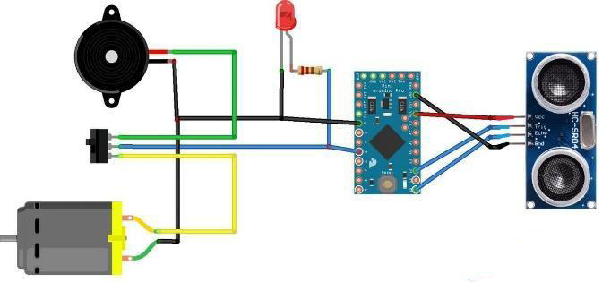

**Fig 3.2: Circuit Diagram of the device**

The equation for the distance calculation between the sensor and the object is as follows:

D = (HPTW * SV)/2

Where, D = Distance in cm.

HPTW = High time of pulse width.

SV = Sound velocity in cm/s.



**Fig 3.3: Detailed circuit diagram**

.

The sensors which are placed in waist belt are in such a manner that the Ultrasonic pulses of sensors must not be overlapped one over the other. Sensors has a field of view (coverage) of about 60 degrees for 4 feet distance, as the distance from the sensor increases, the coverage angle decreases.

Thus, the objective is to cover a wide angle to detect the obstacles with the help of the ultrasonic sensors to help the blind and make it easy for them to move around easily without any hassle. Hence, the distance calculation is calculated and the sensor detects and the further procedure of the buzz sound to the user is carried out.

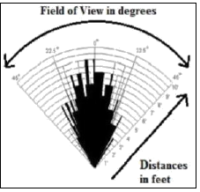

**Fig 3.4: Angle of field of detection**

Thus, this way Third Eye for Blind will be designed for the visually impaired people and will make it very easy and convenient as it will be a wearable device and thus will help the user in travelling and detecting the obstacles while walking very easily.

**3.4 Conclusion :**

Thus, this project proposed the design and architecture of a new concept of Arduino based Virtual Eye for the blind people. A simple, cheap, efficient, easy to carry, configurable, easy to handle electronic guidance system with many more amazing properties and advantages is proposed to provide constructive assistant and support for the blind and visually impaired persons. It is able to scan and detect the obstacles in the areas like left, right, and in front of the blind person regardless of its height or depth. With the proposed architecture, if constructed with at most accuracy, the blind will be able to from one place to another without others help.

**CHAPTER 4**

**PROPOSED SYSTEM**

**4.1 INTRODUCTION:**

The design is based on a special wearable device based on the Arduino board which can be wore like a cloth for blinds. This device is equipped with five ultrasonic sensors, consisting five modules which are connected to the different parts of the body. Among them, two for both the shoulders, another two for both the knees, and one for the vision glass.

With the use of these five ultrasonic sensors , the blind can detect the objects in a five dimensional view around them and can easily travel anywhere by detecting the obstacles. When the ultrasonic sensor detects obstacle the device will notify the user though vibrations and sound beeps.

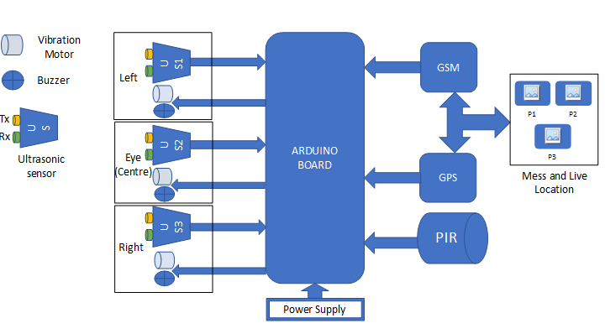

**Fig 4.1: Block Diagram Of Main Control Blocks**

This device will help the blind to navigate without holding a stick which is a bit annoying for them.

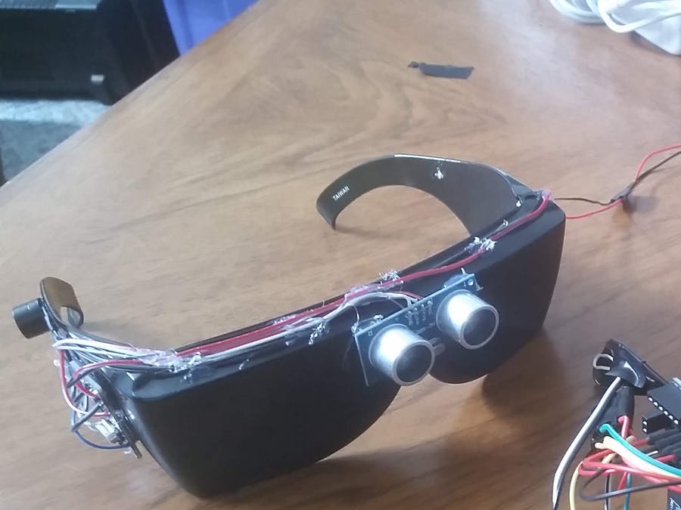

**Fig 4.2:Working Model Of Block Diagram**

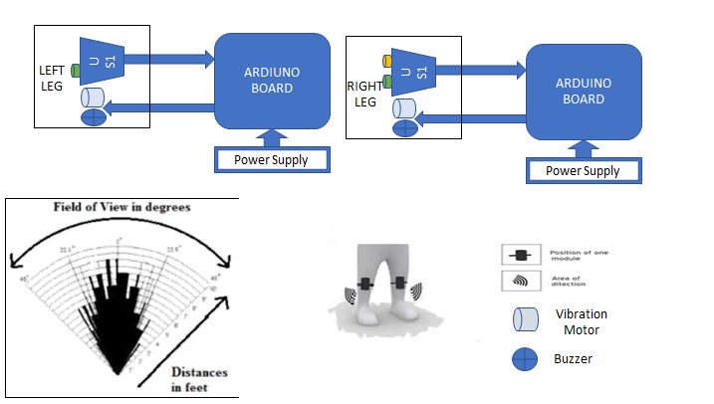

**Fig 4.3: Block Diagram of Right and Left Side Blocks**

Most of the blind persons wore the glass. Our ultimate aim is to fix the sensor along with glass.It is very easy and convenient as it will be a wearable device and thus will help the user in travelling and detecting the obstacles while walking very easily.

**4.2 Basic system architecture:**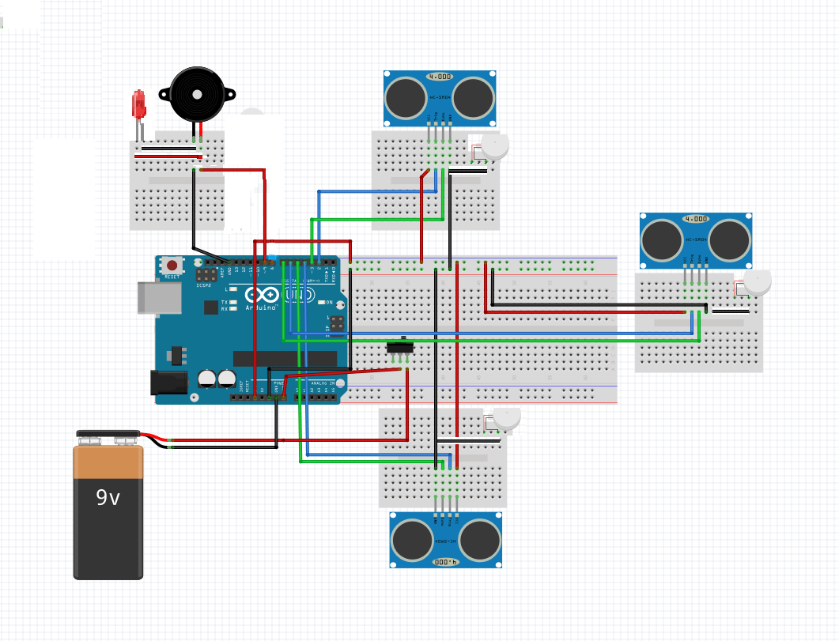

**Fig 4.4: Basic System Architecture**

The design is based on a special wearable device based on the Arduino board which can be wore like a cloth for blinds. This device is equipped with five ultrasonic sensors, consisting five modules which are connected to the different parts of the body. Among them, two for both the shoulders, another two for both the knees, and one for the vision glass.

**CHAPTER 5**

**CONTROLLER BLOCK**

**5.1 ARDUINO UNO:**

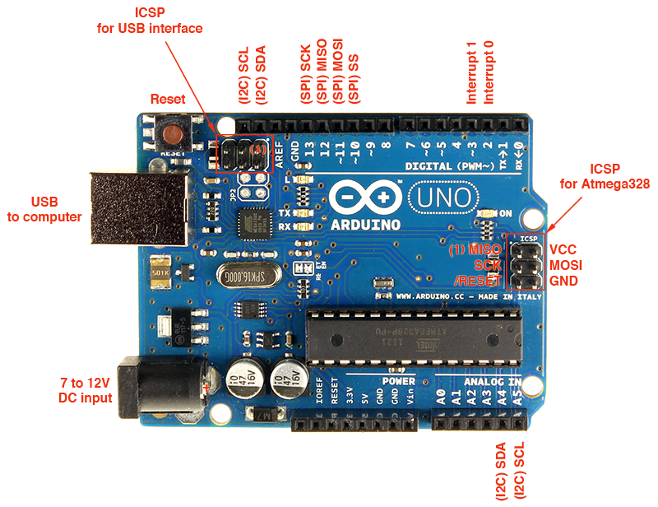

**Fig 5.1:ARDUINO UNO**

The Arduino Uno is a microcontroller board based on the ATmega328(datasheet).It has 14 digital input/output pins(of which 6 can be used as PWM outputs), 6 analog inputs, a 16 MHZ ceramic resonator, a USB connection, a power jack, an ICSP header, and a reset button.

It can be powered by the USB cable or by an external 9-volt battery, though it accepts voltages between 7 and 20 volts. It is also similar to the Arduino Nano and Leonardo, The hardware reference design is distributed under a Creative Commons Attribution Share-Alike 2.5 license and is available on the Arduino website. Layout and production files for some versions of the hardware are also available.

The Uno board is the first in a series of USB-based Arduino boards, it and version 1.0 of the Arduino IDE were the reference versions of Arduino, which have now evolved to newer releases. The ATmega328 on the board comes preprogrammed with a bootloader that allows uploading new code to it without the use of an external hardware programmer.

While the Uno communicates using the original STK500 protocol, it differs from all preceding boards in that it does not use the FTDI USB-to-serial driver chip. Instead, it uses the Atmega16U2 (Atmega8U2 up to version R2) programmed as a USB-to-serial converter.

It contains everything needed to support the microcontroller; simply connect it to a computer with a USB cable or power it with a AC-to-DC adapter or battery to get started. The Uno differs from all preceding boards in that it does not use the FTDI USB-to-serial driver chip. Instead, it features an ATmega16U2 programmed as a USB-to-serial converter. This auxiliary microcontroller has its own USB bootloader, which allows advanced users to reprogram it.

The Arduino has a large support community and an extensive set of support libraries and hardware add-on “shields” (e.g. you can easily make your Arduino wireless with our Wixel shield), making it a great introductory platform for embedded electronics. Note that we also offer a **SparkFun Inventor’s Kit,** which includes an Arduino Uno along with an assortment of components (e.g. breadboard, sensors, jumper wires, and LEDs) that make it possible to create a number of fun introductory projects.

Many Arduino compatible and Arduino derived board exist. Some are functionally equivalent to Arduino and can be used interchangeably. Many enhance the basic Arduino by adding output driver,often for use in school level education,to simplify making buggies and small robots. some variants are use different processors,of varying compatibility.

**Power:**

The Arduino Nano can be powered via the Mini-B USB connection, 6-20V unregulated external power supply (pin 30), or 5V regulated external power supply (pin 27). The power source is automatically selected to the highest voltage source. The FTDI FT232RL chip on the Nano is only powered if the board is being powered over USB. As a result, when running on external (non-USB) power, the 3.3V output (which is supplied by the FTDI chip) is not available and the RX and TX LEDs will flicker if digital pins 0 or 1 are high.

**5.2 SENSORS:**

A sensor is a device that detects and responds to some type of input from the physical environment. The specific input could be light, heat, motion, moisture, pressure, or any one of a great number of other environmental phenomena. The output is generally a signal that is converted to human-readable display at the sensor location or transmitted electronically over a network for reading or further processing.

* + 1. **ULTRASONIC SENSOR: (Ultrasonic Ranging Module HC - SR04)**

Ultrasonic ranging module HC - SR04 provides 2cm - 400cm non-contact measurement function, the ranging accuracy can reach to 3mm. The modules includes ultrasonic transmitters, receiver and control circuit. The basic principle of work: (1) Using IO trigger for at least 10us high level signal, (2) The Module automatically sends eight 40 kHz and detect whether there is a pulse signal back. (3) IF the signal back, through high level , time of high output IO duration is the time from sending ultrasonic to returning. Test distance = (high level time×velocity of sound (340M/S) / 2.

**5.2.1.1 Wire connecting direct as following:**

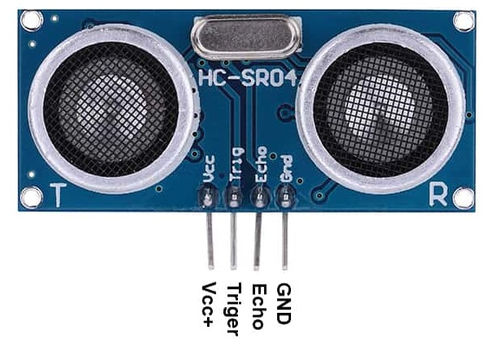

**Fig 5.2: Ultrasonic Sensor**

1. 5V Supply

2. Trigger Pulse Input

3.Echo Pulse Output

4. 0V Ground

**5.2.1.2 Electric Parameter:**

|  |  |
| --- | --- |
| Working Voltage | DC 5V |
| Working Current | 15mA |
| Working Frequency | 40Hz |
| Max Range | 4m |
| Min Range | 2cm |
| Measuring Angle | 15 degree |
| Trigger input Signal | 10uS TTL pulse |
| Echo Output Signal | Input TTL Lever Signal and the range in proportion |

**Table 5.1: Electric Parameter Of Ultrasonic Sensor**

**5.2.1.3 How to detect ultrasonic waves?**

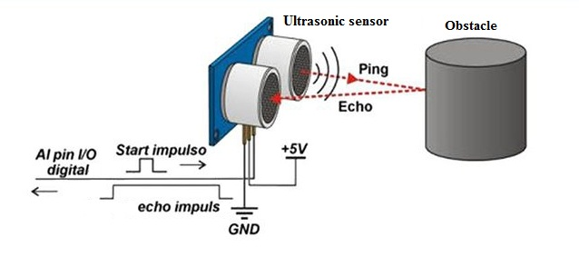

**Fig 5.3: Ultrosonic Sensor Detection**

**5.2.1.4 Timing Diagram:**

The Timing diagram is shown below. You only need to supply a short 10uS pulse to the trigger input to start the ranging, and then the module will send out an 8 cycle burst of ultrasound at 40 kHz and raise its echo. The Echo is a distance object that is pulse width and the range in proportion .You can calculate the range through the time interval between sending trigger signal and receiving echo signal.

Formula:

uS / 58 = centimeters or uS / 148 =inch; or the range = high level time * velocity (340M/S) / 2.

we suggest to use over 60ms measurement cycle, in order to prevent trigger signal to the echo signal.

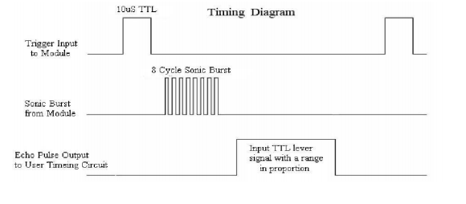

**Fig 5.4: Timing Diagram Of Ultrasonic sensor**

**5.2.1.5 Attention:**

The module is not suggested to connect directly to electric, if connected electric, the GND terminal should be connected the module first, otherwise, it will affect the normal work of the module. When tested objects, the range of area is not less than 0.5 square meters and the plane requests as smooth as possible, otherwise ,it will affect the results of measuring.

**5.2.1.6 Why Not Infra-red Sensor?**

One of the major reasons being that infra-red sensors are not very accurate as compared to ultrasonic ones, I didn't use them for the purpose of detecting obstacles. Moreover, it also doesn't work well in bright sunlight conditions/outdoors and will also pass through transparent objects.

**5.2.1.7 Difference between Ultrasonic Sensor and IR Sensor**:

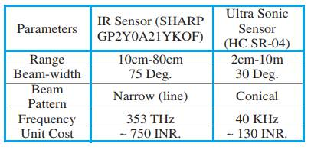

**Table 5.2: Difference Between Ultrasonic and IR Sensor**

* + 1. **PIR SENSOR:**

PIR sensors allow you to sense motion, almost always used to detect whether a human has moved in or out of the sensors range. They are small, inexpensive, low-power, easy to use and don't wear out. For that reason they are commonly found in appliances and gadgets used in homes or businesses. They are often referred to as PIR, "Passive Infrared", "Pyroelectric", or "IR motion" sensors.

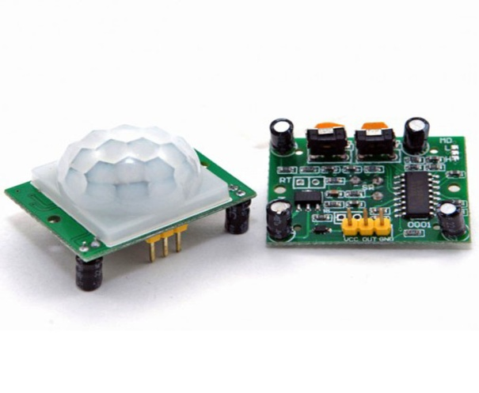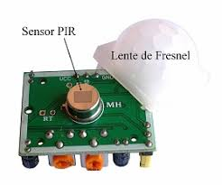

**Fig 5.5: PIR Sensor**

PIRs are basically made of a piezoelectric sensor .which you can see above as the round metal can with a rectangular crystal in the centre), which can detect levels of infrared radiation. Everything emits some low level radiation, and the hotter something is, the more radiation is emitted. The sensor in a motion detector is actually split in two halves. The reason for that is that we are looking to detect motion (change) not average IR levels. The two halves are wired up so that they cancel each other out. If one half sees more or less IR radiation than the other, the output will swing high or low.

Along with the pyroelectic sensor is a bunch of supporting circuitry, resistors and capacitors. It seems that most small hobbyist sensors use the BISS0001 ("Micro Power PIR Motion Detector IC"), undoubtedly a very inexpensive chip. This chip takes the output of the sensor and does some minor processing on it to emit a digital output pulse from the analog sensor.Our new PIRs have more adjustable settings and have a header installed in the 3-pin ground/out/power pads.

**5.2.2.1 Wire connecting direct as following**:

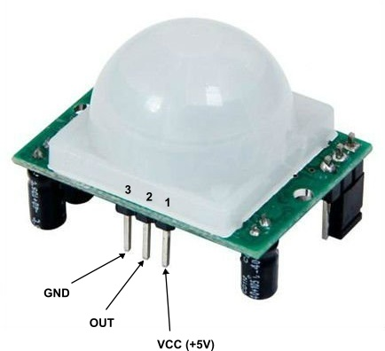

**Fig 5.6: Connection Of PIR Sensor**

|  |  |  |
| --- | --- | --- |
| Pin Number | Pin Name | Description |
| 1 | Vcc | Input Voltage is +5V for typical applications. Can range from 4.5V – 12V |
| 2 | High/Low Output (Dout) | Digital pulse high (3.3V) when triggered (motion detected) digital low(0V) when idle (no motion detected) |
| 3 | Ground | Connected to ground of circuit |

**Table 5.3: Electric Parameter Of PIR Sensor**

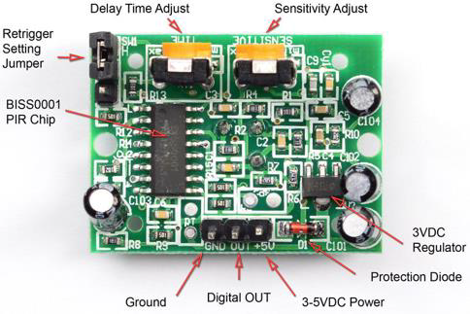

**Fig 5.7: Schematic Design Of PIR Sensor**

**5.2.2.2 How PIRs Work?**

PIR sensors are more complicated than many of the other sensors explained in these tutorials (like photocells, FSRs and tilt switches) because there are multiple variables that affect the sensors input and output. To begin explaining how a basic sensor works, we'll use this rather nice diagram (if anyone knows where it originates plz let me know). The PIR sensor itself has two slots in it, each slot is made of a special material that is sensitive to IR. The lens used here is not really doing much and so we see that the two slots can 'see' out past some distance (basically the sensitivity of the sensor). When the sensor is idle, both slots detect the same amount of IR, the ambient amount radiated from the room or walls or outdoors. When a warm body like a human or animal passes by, it first intercepts one half of the PIR sensor, which causes a positive differential change between the two halves. When the warm body leaves the sensing area, the reverse happens, whereby the sensor generates a negative differential change. These change pulses are what is detected.

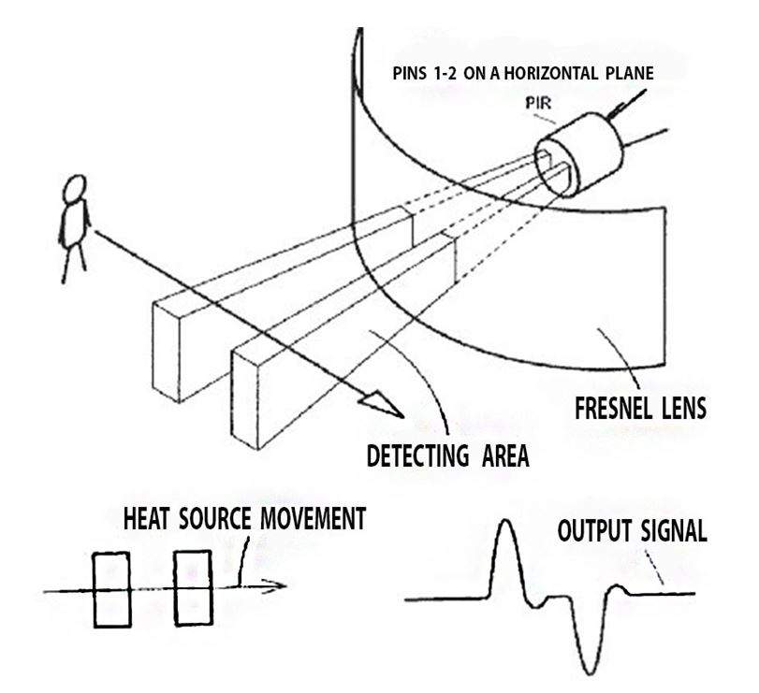

**Fig 5.8: Working Of PIR Sensor**

**5.2.2.3 Retriggering:**

There's a couple options you may have with your PIR. First up we'll explore the 'Retriggering' option. Once you have the LED blinking, look on the back of the PIR sensor and make sure that the jumper is placed in the L position as shown below.

Now set up the testing board again. You may notice that when connecting up the PIR sensor as above, the LED does not stay on when moving in front of it but actually turns on and off every second or so. That is called "non-retriggering".

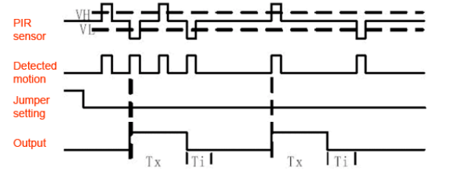

**Fig 5.9: Timing Diagram Of PIR Sensor**

**CHAPTER 6**

**REQUIREMENTS**

**6.1 HARDWARE REQUIREMENTS:**

Hardware details are

6.1.1 Arduino Board

6.1.1.1 Arduino Uno

6.1.1.2 Arduino Nano

6.1.2. Ultrasonic sensors

6.1. 3. PIR Sensor

6.1.4. GPS

6.1.5. GSM

6.1.6. Buzzer

6.1.7. Vibration Motor

6.1.8. LEDs

6.1.9. Switches

6.1.9.1 3 pin Switch

6.1.9.2 4 Pin Switch

6.1.10 Wires

* 1. **SOFTWARE REQUIREMENTS**:

6.2.1 Arduino Software

**6.1.1 Arduino Board:**

**6.1.1.1 Arduino Uno:**

The Arduino Uno is a microcontroller board based on the ATmega328(datasheet).It has 14 digital input/output pins(of which 6 can be used as PWM outputs), 6 analog inputs, a 16 MHZ ceramic resonator, a USB connection, a power jack, an ICSP header, and a reset button.

 It can be powered by the USB cable or by an external 9-volt battery, though it accepts voltages between 7 and 20 volts. It is also similar to the Arduino Nano and Leonardo, The hardware reference design is distributed under a Creative Commons Attribution Share-Alike 2.5 license and is available on the Arduino website. Layout and production files for some versions of the hardware are also available.



**Fig 6.1: Arduino Uno**

The Uno board is the first in a series of USB-based Arduino boards, it and version 1.0 of the Arduino IDE were the reference versions of Arduino, which have now evolved to newer releases. The ATmega328 on the board comes preprogrammed with a bootloader that allows uploading new code to it without the use of an external hardware programmer.

While the Uno communicates using the original STK500 protocol,it differs from all preceding boards in that it does not use the FTDI USB-to-serial driver chip. Instead, it uses the Atmega16U2 (Atmega8U2 up to version R2) programmed as a USB-to-serial converter.

 It contains everything needed to support the microcontroller; simply connect it to a computer with a USB cable or power it with a AC-to-DC adapter or battery to get started.The Uno differs from all preceding boards in that it does not use the FTDI USB-to-serial driver chip. Instead, it features an ATmega16U2 programmed as a USB-to-serial converter. This auxiliary microcontroller has its own USB bootloader, which allows advanced users to reprogram it.

The Arduino has a large support community and an extensive set of support libraries and hardware add-on “shields” (e.g. you can easily make your Arduino wireless with our Wixel shield), making it a great introductory platform for embedded electronics. Note that we also offer a **SparkFun Inventor’s Kit,** which includes an Arduino Uno along with an assortment of components (e.g. breadboard, sensors, jumper wires, and LEDs) that make it possible to create a number of fun introductory projects.

**6.1.1.2 Arduino Nano**

The Arduino Nano is a small, complete, and breadboard-friendly board based on the ATmega328 (Arduino Nano 3.0) or ATmega168 (Arduino Nano 2.x). It has more or less the same functionality of the Arduino Duemilanove, but in a different package. It lacks only a DC power jack, and works with a Mini-B USB cable instead of a standard one. The Nano was designed and is being produced by Gravitech.

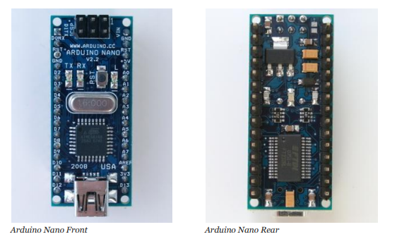

**Fig 6.2: Arduino Nano**

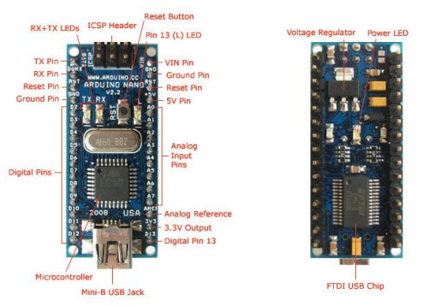

**Fig 6.3: Schematic Design Of Arduino Nano**

**Schematic and Design**

Arduino Nano 3.0 (ATmega328): schematic, Eagle files. Arduino Nano 2.3 (ATmega168): manual (pdf), Eagle files. Note: since the free version of Eagle does not handle more than 2 layers, and this version of the Nano is 4 layers, it is published here unrouted, so users can open and use it in the free version of Eagle.

**Specifications :**

Microcontroller Atmel ATmega168 or ATmega328

Operating Voltage (logic level) 5 V

Input Voltage (recommended) 7-12 V

Input Voltage (limits) 6-20 V

Digital I/O Pins 14 (of which 6 provide PWM output)

Analog Input Pins 8

DC Current per I/O Pin 40 mA

Flash Memory 16 KB (ATmega168) or 32 KB (ATmega328) of which 2 KB used by bootloader

SRAM 1 KB (ATmega168) or 2 KB (ATmega328)

EEPROM 512 bytes (ATmega168) or 1 KB (ATmega328)

Clock Speed 16 MHz

Dimension 0.73" x 1.70"

**Power :**

The Arduino Nano can be powered via the Mini-B USB connection, 6-20V unregulated external power supply (pin 30), or 5V regulated external power supply (pin 27). The power source is automatically selected to the highest voltage source. The FTDI FT232RL chip on the Nano is only powered if the board is being powered over USB. As a result, when running on external (non-USB) power, the 3.3V output (which is supplied by the FTDI chip) is not available and the RX and TX LEDs will flicker if digital pins 0 or 1 are high.

**Memory**

The ATmega168 has 16 KB of flash memory for storing code (of which 2 KB is used for the bootloader); the ATmega328 has 32 KB, (also with 2 KB used for the bootloader). The ATmega168 has 1 KB of SRAM and 512 bytes of EEPROM (which can be read and written with the EEPROM library); the ATmega328 has 2 KB of SRAM and 1 KB of EEPROM.

**6.1.2 Ultrasonic Sensors**:

Ultrasonic ranging module HC - SR04 provides 2cm –400cm non-contact measurement function, the ranging accuracy can reach to 3mm. The modules includes ultrasonic transmitters, receiver and control circuit. The basic principle of work: (1) Using IO trigger for at least 10us high level signal, (2) The Module automatically sends eight 40 kHz and detect whether there is a pulse signal back. (3) IF the signal back, through high level , time of high output IO duration is the time from sending ultrasonic to returning. Test distance = (high level time × velocity of sound (340M/S) / 2.



**Fig 6.4: Ultrasonic Sensor**

**6.1.3 PIR Sensors**:

PIR sensors allow you to sense motion, almost always used to detect whether a human has moved in or out of the sensors range. They are small, inexpensive, low-power, easy to use and don't wear out. For that reason they are commonly found in appliances and gadgets used in homes or businesses. They are often referred to as PIR, "Passive Infrared", "Pyroelectric", or "IR motion" sensors.

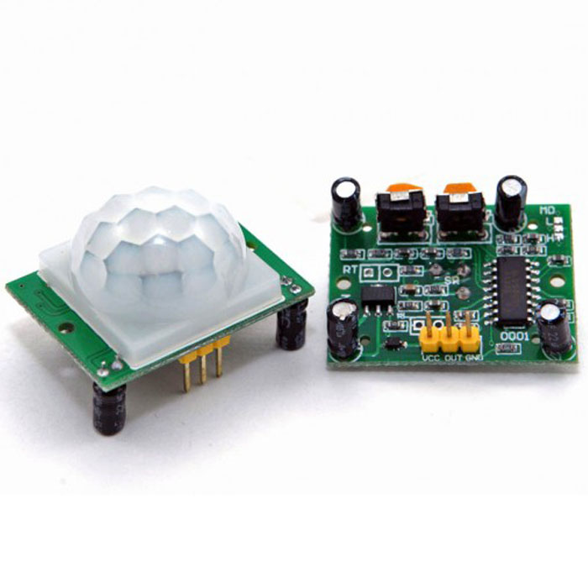

**Fig 6.5: PIR Sensor**

PIRs are basically made of a pyroelectric sensor .which you can see above as the round metal can with a rectangular crystal in the center), which can detect levels of infrared radiation. Everything emits some low level radiation, and the hotter something is, the more radiation is emitted. The sensor in a motion detector is actually split in two halves. The reason for that is that we are looking to detect motion (change) not average IR levels. The two halves are wired up so that they cancel each other out. If one half sees more or less IR radiation than the other, the output will swing high or low.

Along with the pyroelectic sensor is a bunch of supporting circuitry, resistors and capacitors. It seems that most small hobbyist sensors use the BISS0001 ("Micro Power PIR Motion Detector IC"), undoubtedly a very inexpensive chip. This chip takes the output of the sensor and does some minor processing on it to emit a digital output pulse from the analog sensor.Our new PIRs have more adjustable settings and have a header installed in the 3-pin ground/out/power pads.

* + 1. **GPS :**

The goal of this handout is to show you how to use GPS NMEA data and demonstrate some of the features and hardware one finds in embedded GPS modules/receivers. In addition, I will show how the features and hardware can affect tracking accuracy. This is not a buying guide per se, but it will help you get an idea of the differences, shown in Google Earth, between chipsets, antennas, and update rates for the six Spark Fun GPS modules seen below.

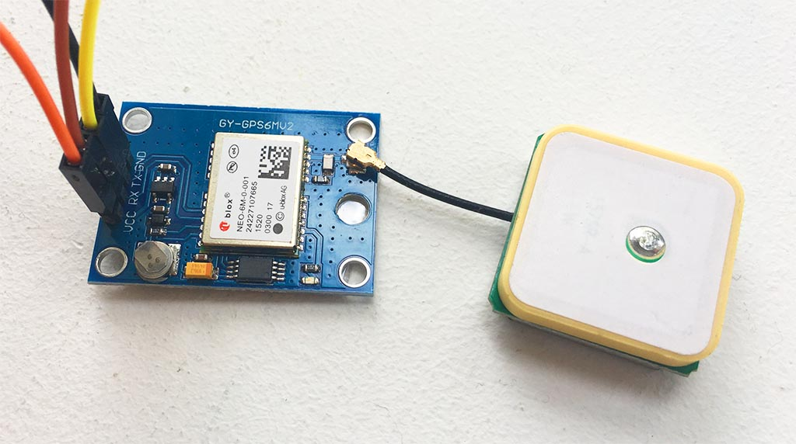

**Fig 6.6: GPS**

I choose modules with different chipsets, antenna/hardware configurations, and update rates in order to get a general idea of the wide variety of features. All modules were left in their default states (except for the SUP500F which I had to configure for 10Hz update rate). The Copernicus and uMini use SMDGPS modules and are assembled by SparkFun. The other four are from outside suppliers.

**Building the tester**

Here is the bill of materials (BOM) for testing each GPS module:

* Breadboard Power Supply Stick 3.3/5V
* LiPo Battery Pack 1000mAh/7.2V
* openlog
* uSD 1GB
* jumper wires and headers

The following are some issues that I had to consider when designing the test rig

**GPS modules are radio frequency receivers.**

For reliable performance, your GPS module needs to receive good unobstructed signals from the satellite constellation. GPS modules have relatively tiny antennas to receive data from satellites moving at relativistic orbital speeds, over 10,000 miles away, and so they need somewhat of a clear view of the sky. I know this might sound really obvious, but I cannot stress this enough, because...

**GPS sensitivity and accuracy is highly dependent on environmental conditions.**

Not only does this include physical objects, like trees, earth, and structures, but also includes atmospheric effects, space weather, the overall health of the GPS constellation, and multipath interactions, all of which contribute to constant variability in receiving the GPS signal. To minimize errors due to these environmental effects, I wanted to test and track all six modules at the same time with varying views of the sky.

What I needed was a mobile logger for each GPS module. SparkFun stocks more than enough supplies to accomplish this.

**6.1.5 GSM :**

This is a very low cost and simple Arduino GSM and GPRS shield. We use the module SIMCom SIM900A. The Shield connects your Arduino to the internet using the GPRS wireless network. Just plug this module onto your Arduino board, plug in a SIM card from an operator offering GPRS coverage and follow a few simple instructions to start controlling your world through the internet. You can also make/receive voice calls (you will need an external speaker and microphone circuit) and send/receive SMS messages.

There are two modules:

1. GSM SHIELD WITH STACKABLE UNO HEADERS ON BOTH SIDES(WITH NOMIC AND SPEAKER)

2. GSM SHIELD WITH SINGLE UNO HEADERS WITH MIC AND SPEAKER

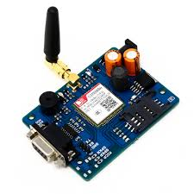

**Fig 6.7: GSM**

**Features**

• Dual-Band GSM/GPRS 900/ 1800 MHz.

• RS232 interface for direct communication with computer or MCU kit.

• Configurable baud rate.

• Power controlled using 29302WU IC.

• ESD Compliance.

• Enable with MIC and SPeaker socket.

• With slid in SIM card tray.

• With Stub antenna and SMA connector.

• Input Voltage: 12V DC.

**6.1.6 Buzzer:**

A Buzzer or beeper is an audio signaling device, which may be mechanical, electromechanical, or piezoelectric.Typical uses of buzzers and beepers include alarm devices, timers and confirmation of user input such as mouse click or key stroke.Buzzer is an integrated structure of electronic transducers, DC power supply, widely used in computers, printers, copiers, alarms, electronic toys, automotive electronic equipment, telephones, timers and other electronic products for sound devices. Active buzzer 5V Rated power can be directly connected to a continuous sound, this section dedicated sensor expansion module and the board in combination, can complete a simple circuit design, to “plug and play”.

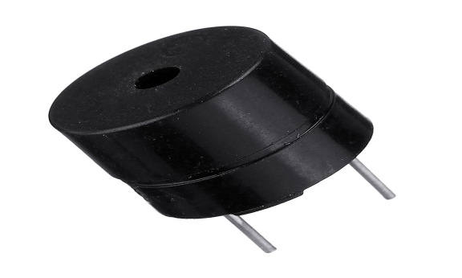

**Fig 6.9: Buzzer**

**PRODUCT DESCRIPTION :**

A buzzer or beeper is an audio signalling device, which may be mechanical, electromechanical, or piezoelectric. Typical uses of buzzers and beepers include alarm devices, timers, and confirmation of user input such as a mouse click or keystroke.

It generates consistent single tone sound just by applying D.C voltage.  
Using a suitably designed resonant system, this type can be used where large sound  
volumes are needed. At Future Electronics we stock many of the most common  
types categorized by Type, Sound Level, Frequency, Rated Voltage, Packaging Type.  
 **FEATURES**• Input supply: 5 VDC

• Current consumption: 9.0 mA max.  
• Oscillating frequency: 3.0 ±0.5 KHz  
• Sound Pressure Level: 85dB min.

**APPLICATIONS**• Confirmation of user input (ex: mouse click or keystroke)  
• Electronic metronomes  
• Sporting events  
• Judging Panels  
• Annunciator panels

**6.1.7 Vibration motor:**

Vibration motor is a coreless DC motor and the size of this motor is compact. The main purpose of this motor is to alert the user from receiving the call by without sound/vibrating. These motors are applicable for different applications like pagers, handsets, cell phones, etc. The main feature of this motor is, it has magnetic properties, lightweight, and motor size is small. Based on these features, the motor performance is highly consistent. The configuration of these motors can be done in two varieties one is coin model and another one is a cylinder model. The vibrator motor specifications mainly include type, max operating torque, max.centrifugal force, weight range, rated current and output.

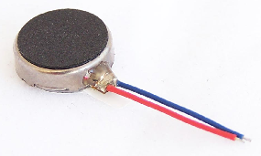

**Fig 6.10: Vibration Motor**

### Vibrator Motor Applications :

1. These motors are extensively used in a range of applications like handsets, cell phones, pagers, etc
2. These motors are used in numerous material handling devices like conveyors, feeder, and vibrating screens.
3. These are also utilized on hoppers, silos to stop blocking of the flow of material.
4. These are used in compacting machines & foundry shakeouts for quick & proficient operation.
5. Vibrator motor Arduino can be used to control the motorProcessing.

**6.1.8 LEDs:**

A Light emitting diode (LED) is essentially a pn junction diode. When carriers are injected across a forward-biased junction, it emits incoherent light. Most of the commercial LEDs are realized using a highly doped n and a p Junction.In 1962 the first red LED was developed by Nick Holonyak at G.E. Throughout the 60’s red LEDs were ued as small indicator lights on electronic devices. Green and yellow LEDs were introduced.n the early 70’s, and were used in electronics, traffic signals, exit signs, and watches, etc.

By 1990, LEDs of one lumen output were available. In 1993, Shuji Nakamura at Nichia created the first high-brightness blue LED, making it possible to RGB mix to any color. This was followed in 1996 by the development of Phosphor White LEDs, which combined a blue or ultraviolet LED with a phosphor coating that produced white light. By 2005, output levels of 100 lumens were possible. white light LEDs became available in various shades. LEDs began competing with conventional light sources and fixtures in general illumination applications. The Department of Energy expects LED technology to become the preferred method of lighting in homes and offices by 2025.

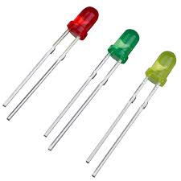

**Fig 6.11: LEDs**

**Working:**

Like a normal diode, the LED consists of a chip of semiconducting material impregnated, or doped with impurities to create a p -n, (positive / negative) junction. Atoms in the n -type material have extra electrons, atoms in the p - type material have electron holes. Applying current pushes the atoms toward the junction. When they get close, the n -type atoms ’donate’ their extra electrons to the p -type atoms which ‘accept’ them. A negative charge to the n - side allows current to flow from the ( -) charged area to the ( + ) charged area. This is called ‘forward bias’.

When extra electrons in the n-type material fall into the holes in the p-type material, they release energy in the form of photons. The material in an LED is selected so that the wavelength of the photons falls within the visible portion of spectrum. Different materials produce photons at different wavelengths / color.

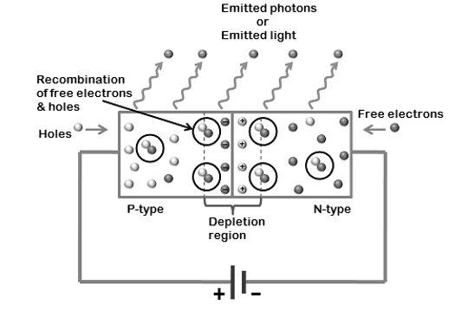

**Fig 6.12: Structure Of LED**

**6.1.9 Switches:**

**6.1.9.1 3 pin Switch**

**6.1.9.2 4 pin Switch**

**6.1.9.1 3 pin Switch :**

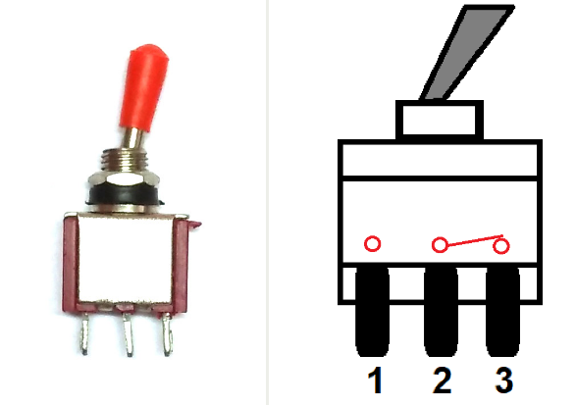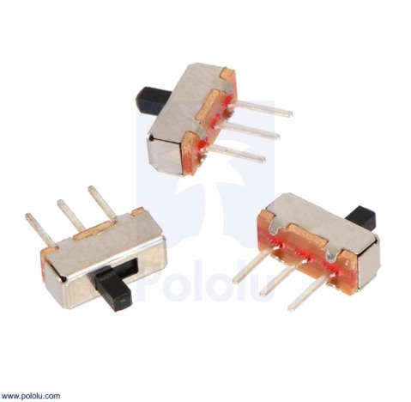

**Fig 6.13: 3 pin Switch**

|  |  |  |
| --- | --- | --- |
| **S.No** | **Pin Name** | **Description** |
| 1. | A | Output 1 |
| 2. | COM | Input |
| 3. | B | Output 2 |

**Table 6.1: 3 pin Switch**

**Features and Specifications**

* 0.4volt-amps (max.) contact rating at 20v AC or DC (max.)
* Mechanical Life: 30,000 make-and-break cycles.
* 20mΩ (max.) contact resistance
* 100MΩ (min.) of Insulation Resistance
* 100mAfor both silver and gold plated contacts.
* Dielectric strength of 1000VRMS at sea level.
* Operating Temperature: -30°C to 85°C.

**Brief about Toggle Switch?**

There are four types of switches, classified below:

* Single Pole Single through (SPST)
* Single pole double throw (SPDT)
* Double pole, single throw (DPST)
* Double pole double throw (DPDT)

**SPDT Toggle Switch** is a three terminal switch, only one is used as input other two are as output. Therefore, we get two outputs, one from COM and A and second is from COM and B, but only one at a time. Mainly it is used in three-way circuit to turn **ON/OFF** an electrical appliance from two location.

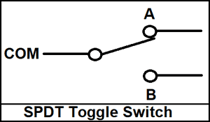

**Fig 6.14: SPDT Toggle Switch**

**6.1.9.2 4 pin Switch**

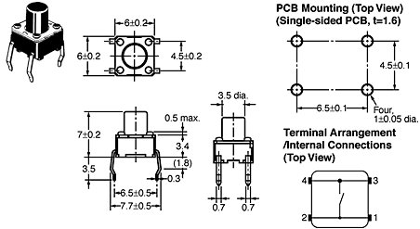

**Fig 6.15: 4 pin Switch**

**Product Description:**

Miniature 4-PIN Single Pull Single Throw switches. These are high quality momentary on switches. Perfect as a tactile reset switch. Mounts directly into standard breadboards. Rated up to 50mA.  
  
**Features:**  
• Power Rating: MAX 50mA 24VDC  
• Contact Resistance: MAX 100mOhm  
• Dielectric Withstanding Voltage: 250VAC for 1 minute  
• Contact Bounce: MAX 5mS  
• Operating Force: 2.55 +/-0.69 N  
• Return Fource: MIN 0.49 N  
• Travel 0.25 +0.2/-0.1 mm

* 1. **SOFTWARE SPECIFICATIONS**

**6.2.1 ARDUINO SOFTWARE**

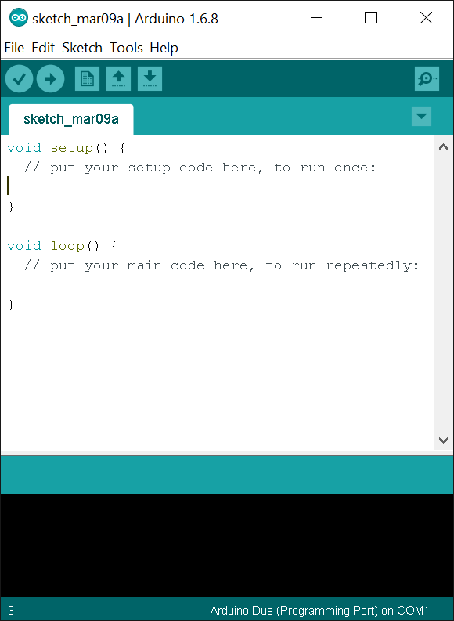

**Fig 6.16: Arduino IDE**

Arduino IDE is an open source software that is mainly used for writing and compiling the code into the Arduino Module. It is an official Arduino software, making code compilation too easy that even a common person with no prior technical knowledge can get their feet wet with the learning process. It is easily available for operating systems like MAC, Windows, Linux and runs on the Java Platform that comes with inbuilt functions and commands that play a vital role for debugging, editing and compiling the code in the environment. A range of Arduino modules available including Arduino Uno, Arduino Mega, Arduino Leonardo, Arduino micro and many more. Each of them contains a microcontroller on the board that is actually programmed and accepts the information in the form of code. The main code, also known as a sketch, created on the IDE platform will ultimately generate a Hex File which is then transferred and uploaded in the controller on the board. The IDE environment mainly contains two basic parts: Editor and Compiler where former is used for writing the required code and later is used for compiling and uploading the code into the given Arduino Module. This environment supports both C and C++ languages.

**6.2.2 ARDUINO FEATURES**

The main features of Arduino IDE are,

* Sketch Editing Tools
* Libraries
* Serial Monitor
* Programmer Functions
* Burn Bootloader
* Sketches Management
* Sharing
* Auto Format
* User Preferences